Target Financial Sanctions Page Requirements

## **1. Purpose of the document**

The purpose of this document is to highlight some requirements requested by the Committee for Goods & Material Subjected to Import & Export Control in addition to the design that was provided in an XD link and approved:

<https://xd.adobe.com/view/5a34efde-a5bd-4507-b3d3-d12c4d2f1c9f-0f67/screen/4c800ad4-7834-4af1-b69c-c4a97938ae18/>

## **2. Side Menu Requirements**

### **2.1 In the side menu, sub menu**

* + When you hover over the title the color shall change of the text is not visible

1. Upon hovering any item in the side menu, it will be underlined to show the use it is clickable to be consistent with the rest of the portal
2. The main item in the side menu will be displayed bold (same as design) if selected
3. The sub items in the side menu will be displayed in Gold (same as design) if selected

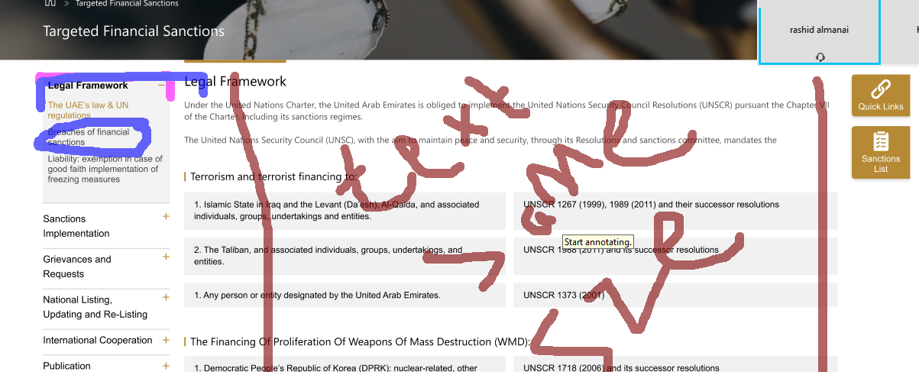

### **2.2 Quick Links & Sanctions list**

1. The first Icon “Quick Links” shall include the following links as content

* [UNSCR 1267 List](https://www.un.org/securitycouncil/sanctions/1267/aq_sanctions_list)
* [UNSCR 1988 List](https://www.un.org/securitycouncil/sanctions/1988/materials)
* [UNSCR 1718 List](https://www.un.org/securitycouncil/sanctions/1718/materials)
* [UNSCR 2231 List](https://www.un.org/securitycouncil/content/2231/list)
* Contact information
* CABINET DECISION NO (xxx) of 2020
* AML/CFT Law XXX
* FAQ

1. The second icon “Sanction List” shall include the following:
2. Below links as content
   * UAE National List
   * UN Consolidated List

In addition to Subscribe to Sanction Lists as a button same as design

1. The Sanctions list design should follow the same design as quick links

## **3. Subscription Requirements**

### **3.1 Banner**

* The subscription banner looks good and to be included in each subtitle “Sanctions Implementation”. In other words, the subscription banner will not appear in any page except the pages under Sanctions Implementation pages accessed from the side menu

*Note: This component cannot be managed from the admin and has to be added by development team if requested in any other page under the Target Financial Sanctions page*

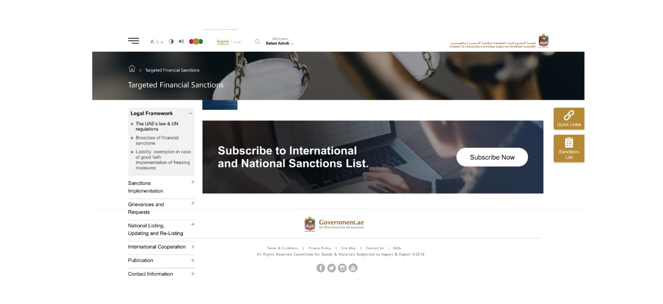

### **3.2 In the subscribe form**

* + The user shall be prompt to select either a individual or company registration
  + For company registration the following fields
    - 1st field to be to “Company Name - Arabic ” Mandatory field
    - 2nd field to be to “Company Name - English ” Mandatory field
    - 3rd field “Type of Business” Mandatory field – in case user chose Other, text field will be displayed for the user to enter it manually
    - 4th field “Subscriber Email” Mandatory field and unique
  + For individual registration the following fields
    - 1st Field “Personal Name – Arabic” Mandatory field
    - 2nd field “Personal Name - English” Mandatory field
    - 3rd field “Type of Business” Not Mandatory field
    - 4th field “Subscriber Email” Mandatory field and unique

*Note: Save the subscription date on the Database to be displayed in the admin’s site*

**Type of Business**

•        Dealer in precious metals and stones

•        Accounting firm, audit firm, insolvency firm or taxation consulting firm;

•        Law firm, notary firm or other independent legal business;

•        Company Service Provider.

•        Banks

•        Exchange houses

•        Finance companies

•        Brokerage firms (Securities/Insurance)

•        Insurance/reinsurance companies

•        Asset/Fund managers

•        Private individual

•        Other [the user shall be able to enter it manually]

### **1.3 Sending Notifications**

* Send the UN sanctions updates (notification upon adding a link from the admin) from two different emails, one email for the tracker emails (sanctions email) and the other one is for the subscribers (no_reply email)

## **4. General Requirements for the page**

* The tables representation from the word document to the website need to be re-designed for correct interpretation by the user. The white space between the columns of cells on the same row needs to be removed and replaced with separator, as for the white space between rows under each other will leave it

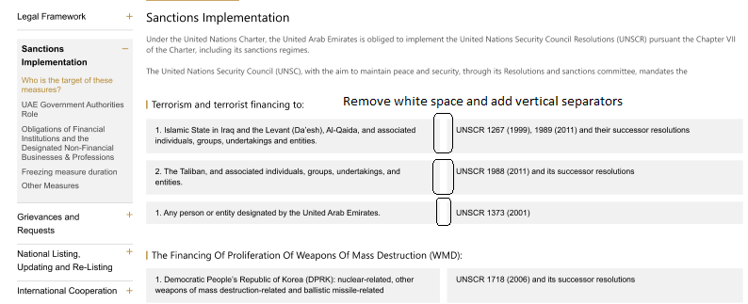

* The “documents” and “Related content” shall only be visible when there are documents included in the subsection, this feature to be controlled from the admin.
* The Admin page shall have the functionality to change and edit the content of the Targeted Financial Sanctions Page. Also, add or remove related documents and links.
* Under the section: Sanctions implementation - Who is the target of these measures?

By clicking on the UN icon, the user shall be prompted to select the form of the requested file, HTML, PDF and XML. Similar to the current page]

[United Nations Security Council Consolidated List](https://www.un.org/securitycouncil/content/un-sc-consolidated-list)

* Under the section: Changes to the lists:

This section to include the changes occur on the list (which is already in the design)

## **5. Administration Requirements**

### **5.1 UN Recipients List – Create New**

* In case Tracked checkbox is not checked, the form will be as follows:
  + The user shall be prompt to select either a individual or company registration
  + For company registration the following fields
    - 1st field to be to “Company Name - Arabic ” Mandatory field
    - 2nd field to be to “Company Name - English ” Mandatory field
    - 3rd field “Type of Business” Mandatory field – in case user chose Other, text field will be displayed for the user to enter it manually
    - 4th field “Subscriber Email” Mandatory field and unique
  + For individual registration the following fields
    - 1st Field “Personal Name – Arabic” Mandatory field
    - 2nd field “Personal Name - English” Mandatory field
    - 3rd field “Type of Business” Not Mandatory field
    - 4th field “Subscriber Email” Mandatory field and unique
* In case Tracked checkbox is checked, the form will be as follows:
  + - 1st field to be to “Company Name - Arabic ” Mandatory field
    - 2nd field to be to “Company Name - English ” Mandatory field
    - 3rd field “Subscriber Email” Mandatory field and unique

Admin will have the option to add multiple emails, if more than one email added they will all receive notifications in case new UN link added

* + - 4th field, 5th fields:
* Contact Person Name - Mandatory field
* Mobile Number - Mandatory field

Admin will have the option to add multiple mobile numbers associated with contact person name per each mobile

*Notes:*

*1. The email and mobile is mandatory for the first entry then it is optional to add more*

*2. Save the creatio date on the Database to be displayed in the listing page*

### **5.2 UN Recipients List – Listing Page**

* Filtration:
  + - 1st field to “Recipient Name” – To accept Arabic or English
    - 2nd field to be “Recipient Email”
    - 3rd field to be “Recipient Type” – Drop down (Tracked & Subscribers) - combine results of not tracked and subscribers to be under subscribers
    - 4th field to be “Business Type”
* Listing
* 1st field to be “Recipient Name - Arabic”
* 2nd field to be “Recipient Name - English”
* 3rd field to be “Business Type”
* 4th field to be “Subscription/Creation date”

Admin should have the option in the UN Recipients list to export recipients to an excel sheet.

|  |  |  |  |
| --- | --- | --- | --- |
| **Section 2 - Reviewer** | | | |
| **Reviewed By:** | Name | Signature | Date |
| **EM – LINK dot NET** | Hend Mohamed |  | **21/06/2018** |
| **PM – IECEO** | Rashid Mattar  Saeed Hamad Saeed Aleghfeli |  |  |
| **Section 3 - Approval** | | | |
| **Approved by:** |  | | |
| **Signature:** |  | | |