

Link Development

Challenge for Technical Writers

Creation Date: 1/31/2019

**Egypt HQ**: A: 94, Street 105, 11431 Maadi, Cairo, Egypt.

**T:** +02 2529 5800 **F:** +02 2529 5888 **E:** [info@linkdev.com](mailto:info@linkdev.com) [www.linkdevelopment.com](http://www.linkdevelopment.com)



# Challenge Goals

This challenge consists of four sections. We will evaluate the following elements:

* Your English grammar and spelling skills.
* Your ability to structure text.
* Your ability to create new content.
* Your ability to distribute and structure content to create a better user experience.
* Your ability to use different resources to develop a certain subject.
* Your experience and criteria as a technical writer.
* Your understanding of programming and technical concepts.
* Your thinking process when developing documentation.

Challenge Rules

* Challenge Duration is 60 MINUTES.
* Feel Free to use online search while providing your answer

# The Challenge

Write the steps for making a Peanut Butter-Jelly sandwich.

The constraints to keep in mind are:

* You need to use a healthy bread option.
* You also need to use a fruit of your choice in the sandwich.

**Your Answer:**

This section presents five messages that your development team shared with you. They want you to review them and rewrite, if you feel they are not up to the mark. Rewrite the messages with a justification for why you changed the message. If you did not change the message, explain why you left it as-is.



**Revised message:**

**Justification**:

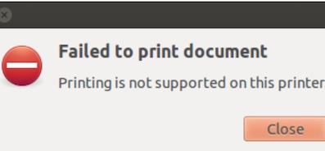

**Revised message:**

**Justification:**

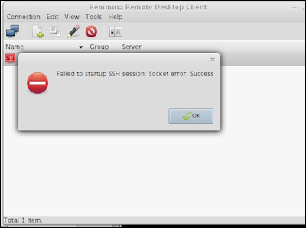

**Revised message:**

**Justification:**

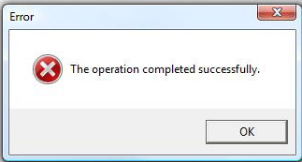

**Revised message:**

The operation is completed successfully

**Justification:**

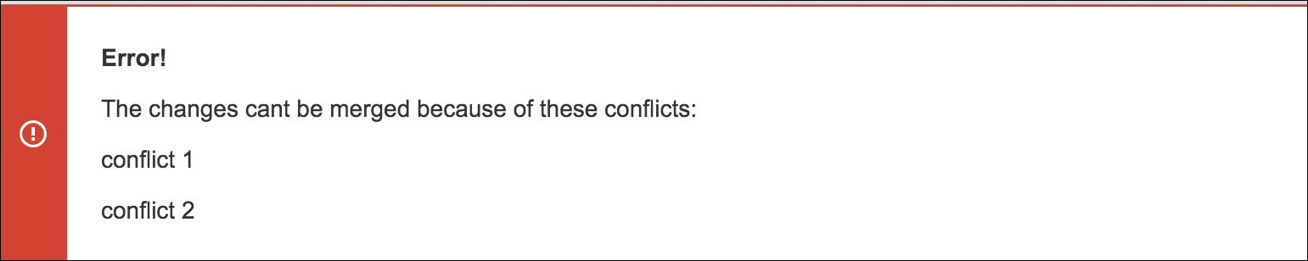

**Revised message:**

**Justification:**